Processing Multispectral Images in Pix4D for Agricultural Research

Taylor Nelsen

March 20, 2019

*This standard operating procedure (SOP) was written based on Pix4D Version 4.3.31.*

# Introduction

Collecting research quality data with small Unmanned Ariel Systems (UAS) requires users to be aware of the many factors that can affect their platform and its data outputs. This SOP outlines the method of processing multispectral images in Pix4D. It assumes the images are of research grade quality and were flown regarding best practices.

# Set-up a consistent image file structure

Images should be stored in a organized and consistant fashion. The recommended file structure is as follows: YEAR > SITE > CAMERA > IMAGE FILES. For example, 2019 > Davis > RedEdgeM > ... When transferring images from the camera's SD card keep the image files in the folders they are automatically organized into

# Process images in Pix4D

1. Open Pix4D Desktop
2. From the home screen choose “Project” > “New Project” or Ctrl+N on a Windows machine.

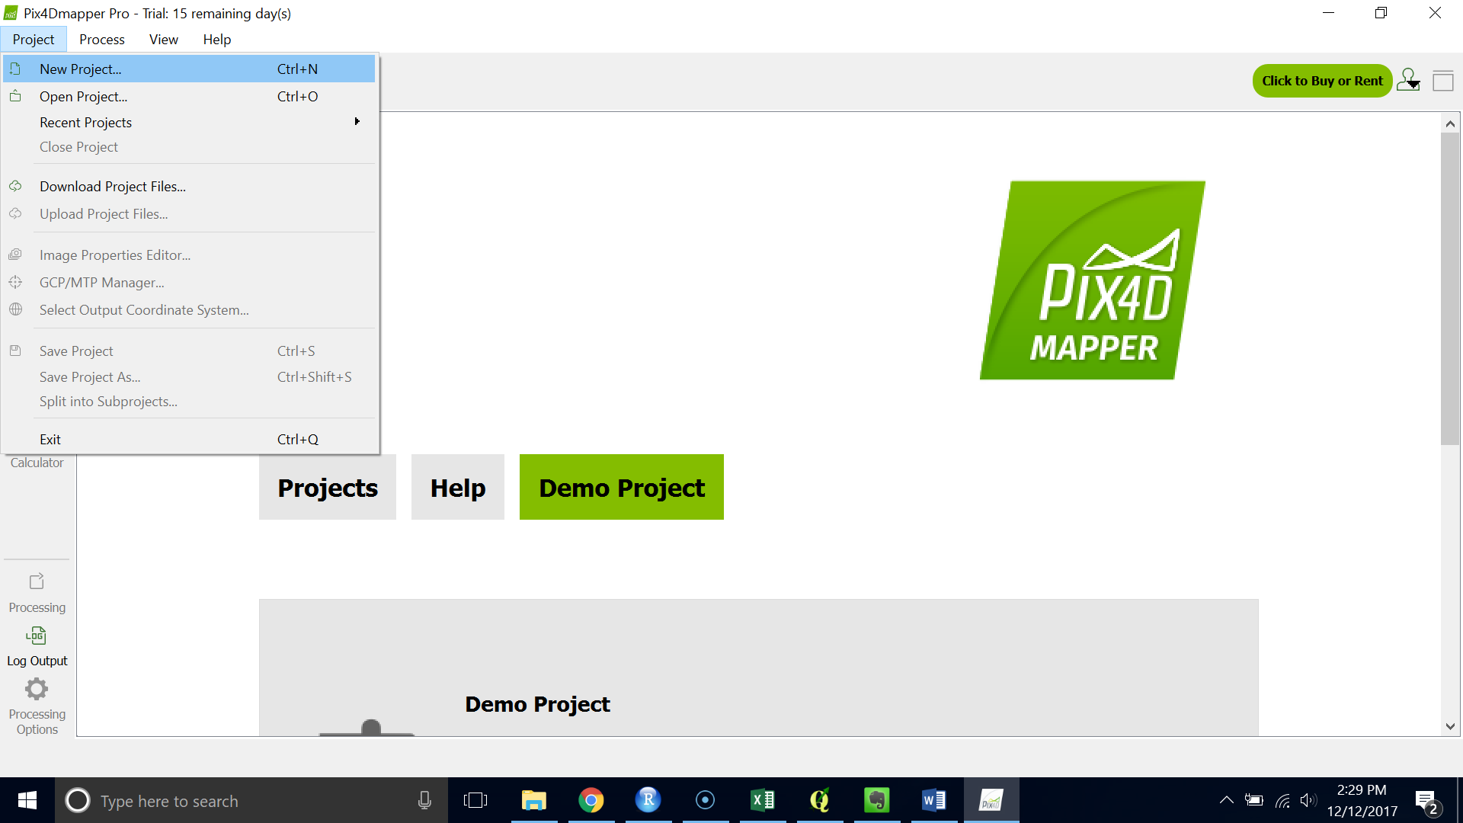

1. Name your project with location_date for example Davis_2l11l17 (this is the recommended naming format but not required)
2. Press “Next >”

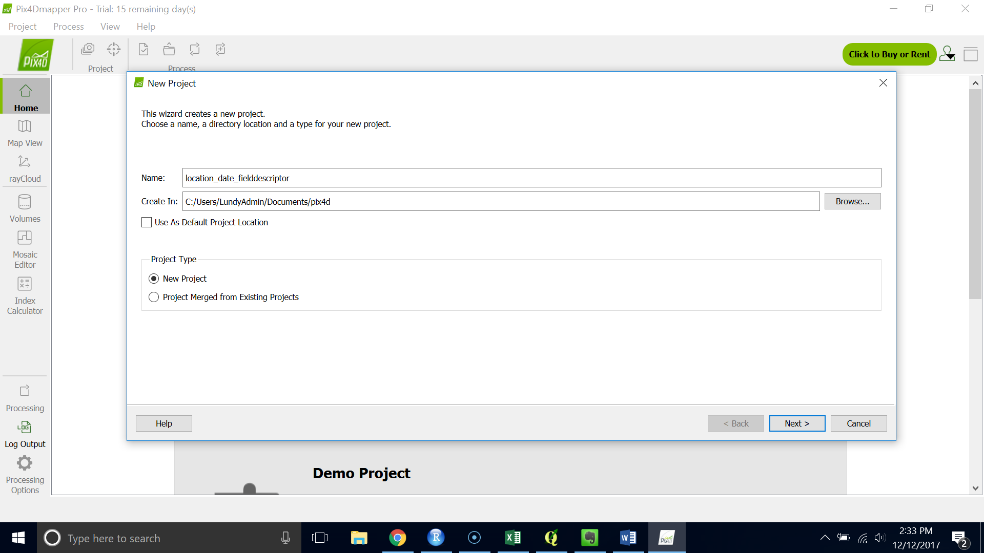

1. Choose “Add Directories” and navigate to your image database.

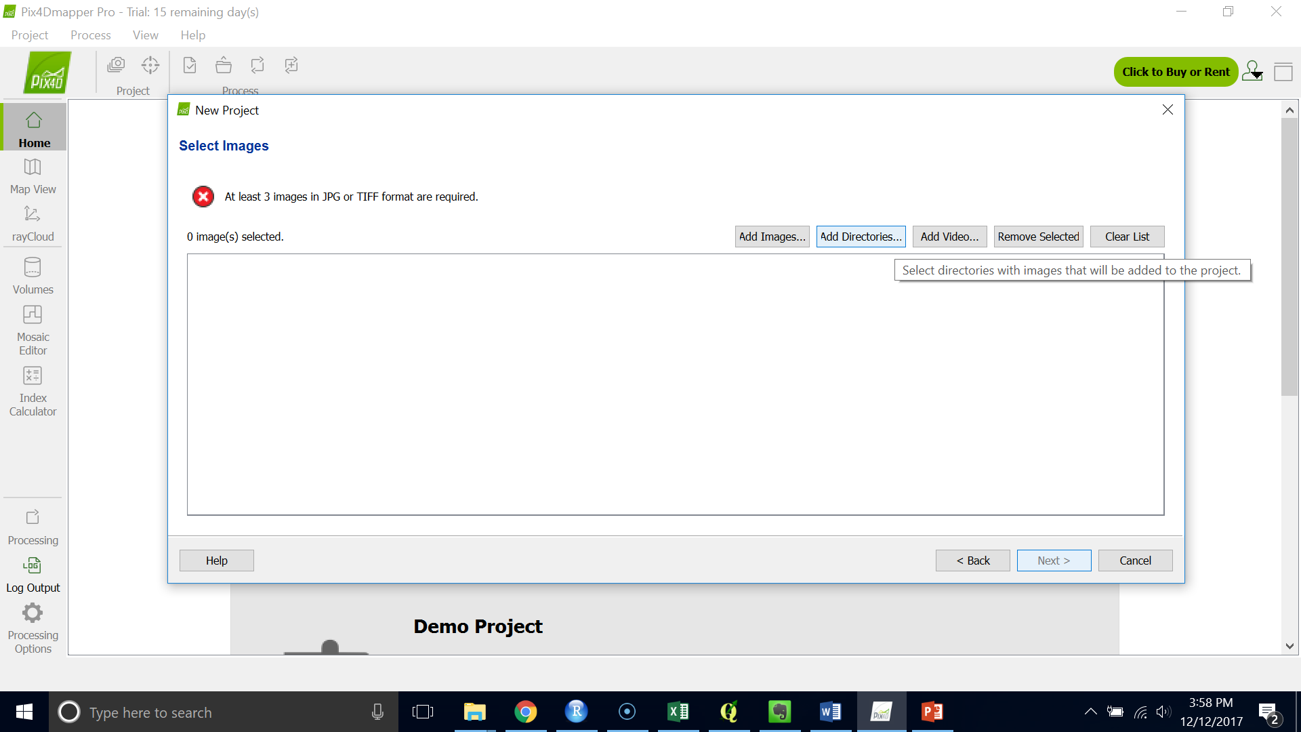

1. Highlight the directories and click “Choose” 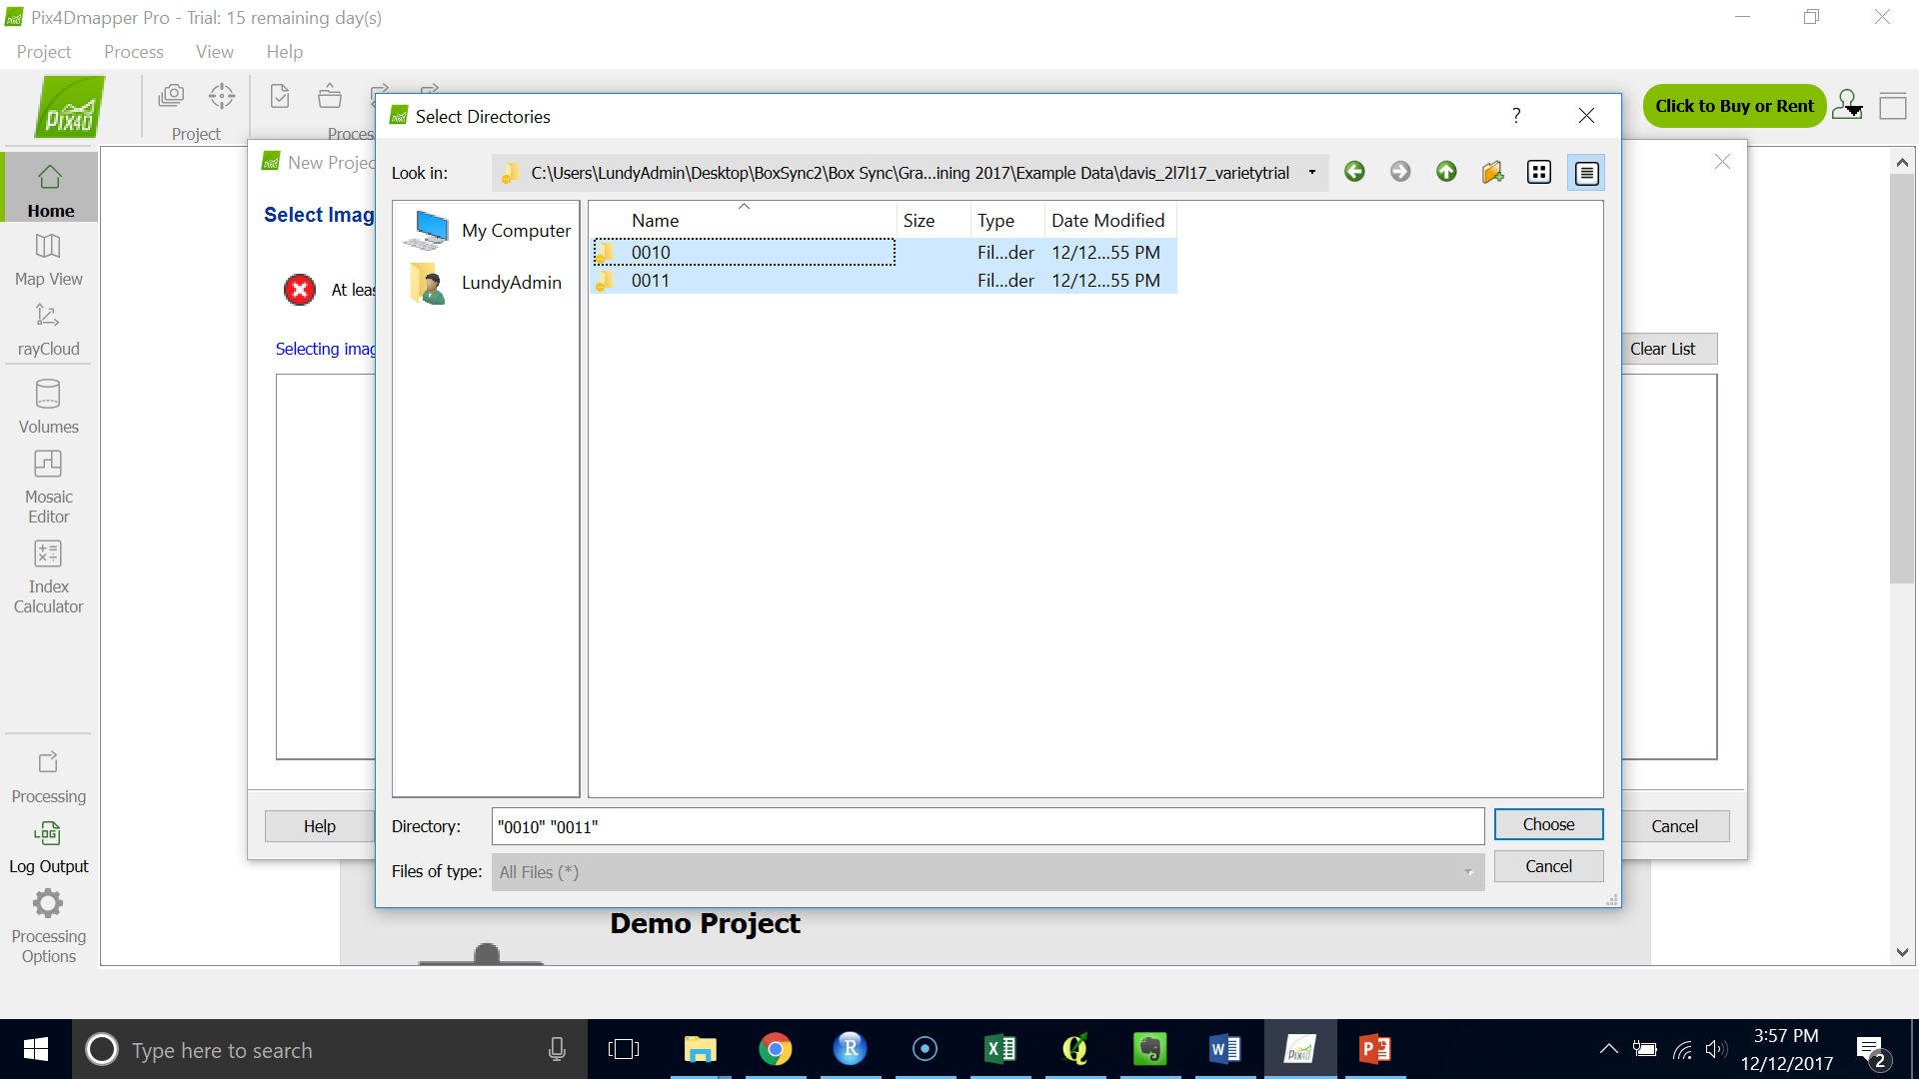
2. You should see a green check in the top left corner. Click “Next >”

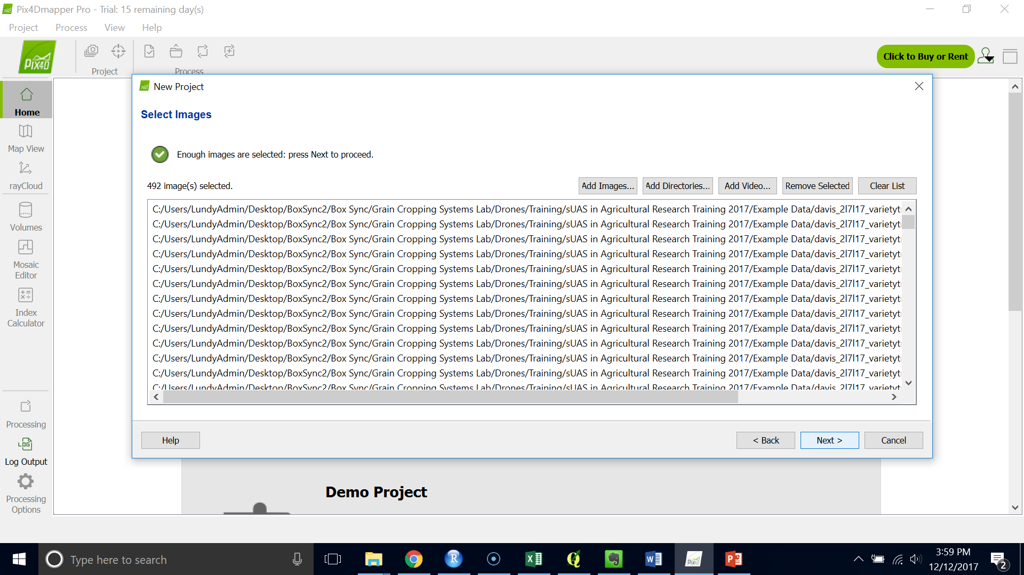

1. If you try to load both RGB and TIFF images Pix4D will not allow you to process them images together.

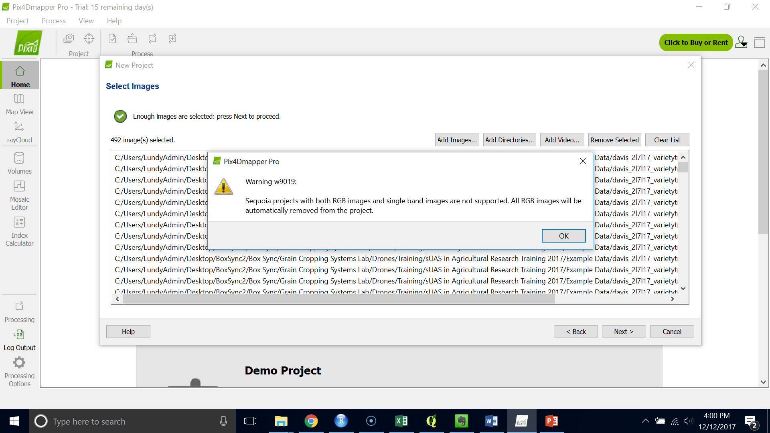

1. Make sure all the images and their geolocations are being read by the program.
2. Click “Next >”

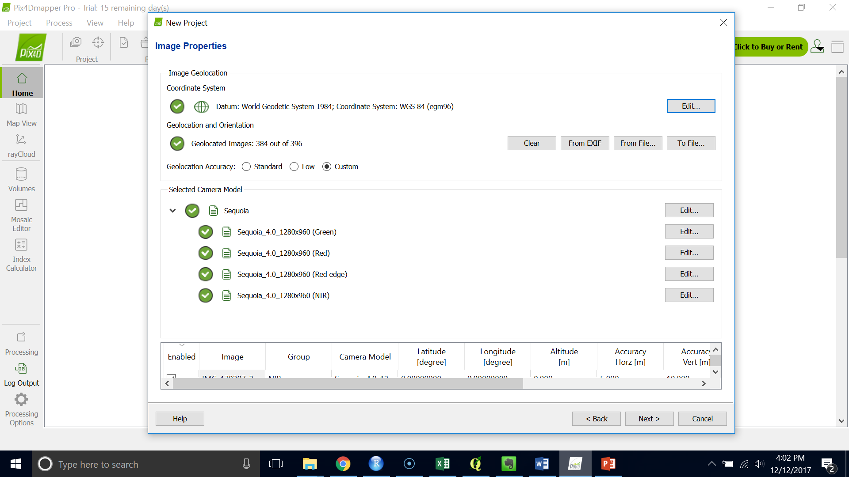

1. You can change the output coordinate system but it is fine to leave the auto detected one.

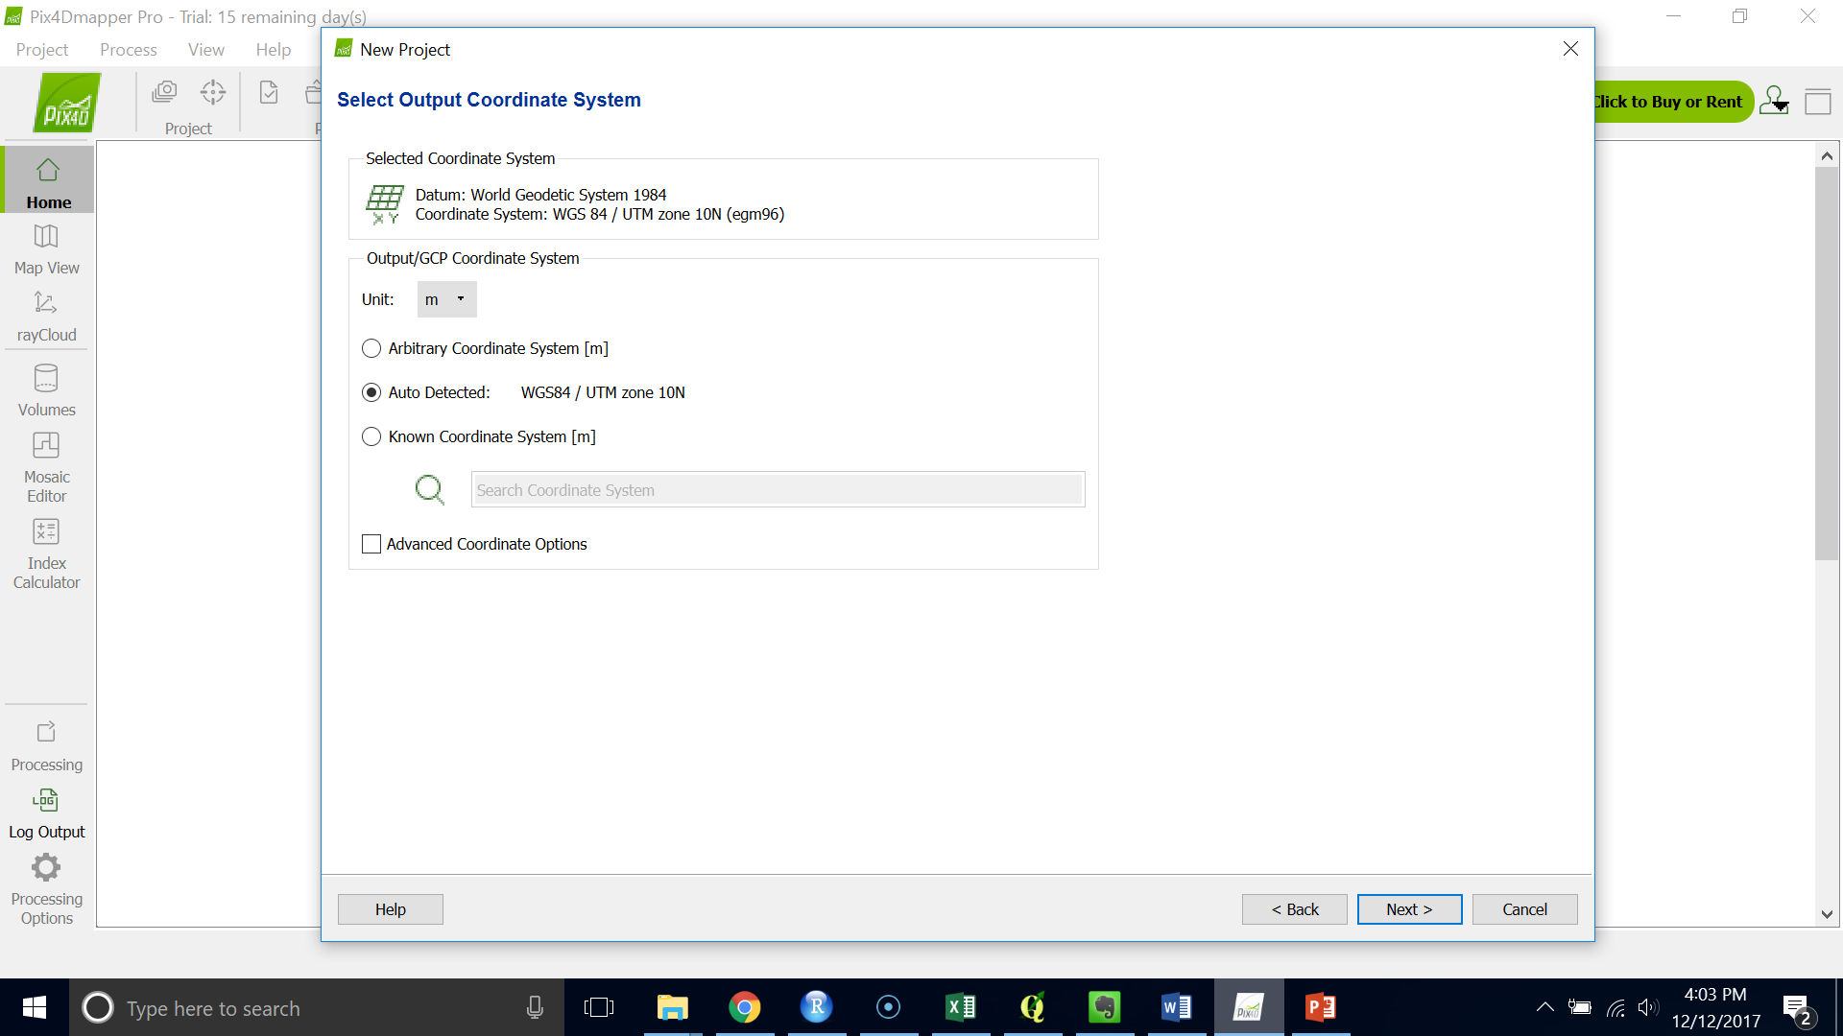

1. Choose the “Ag Multispectral” Processing Template. Make sure the “Start Processing Now” box is unchecked. Click “Finish.”

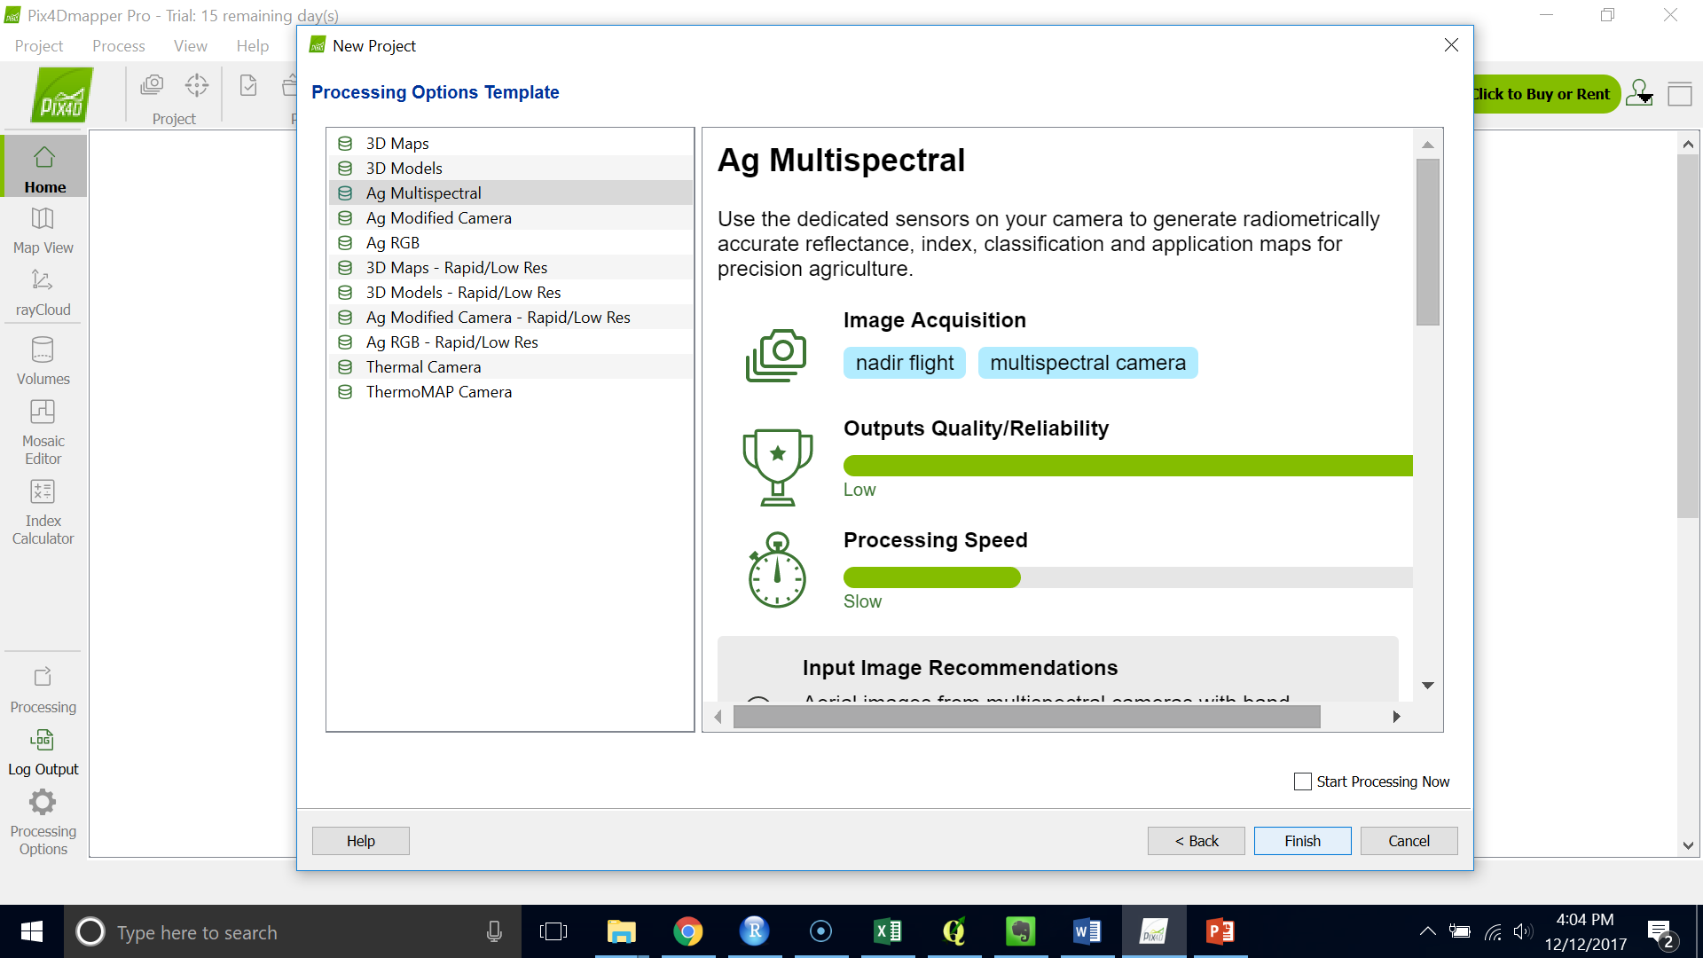

1. You should see a red dot for each image location.

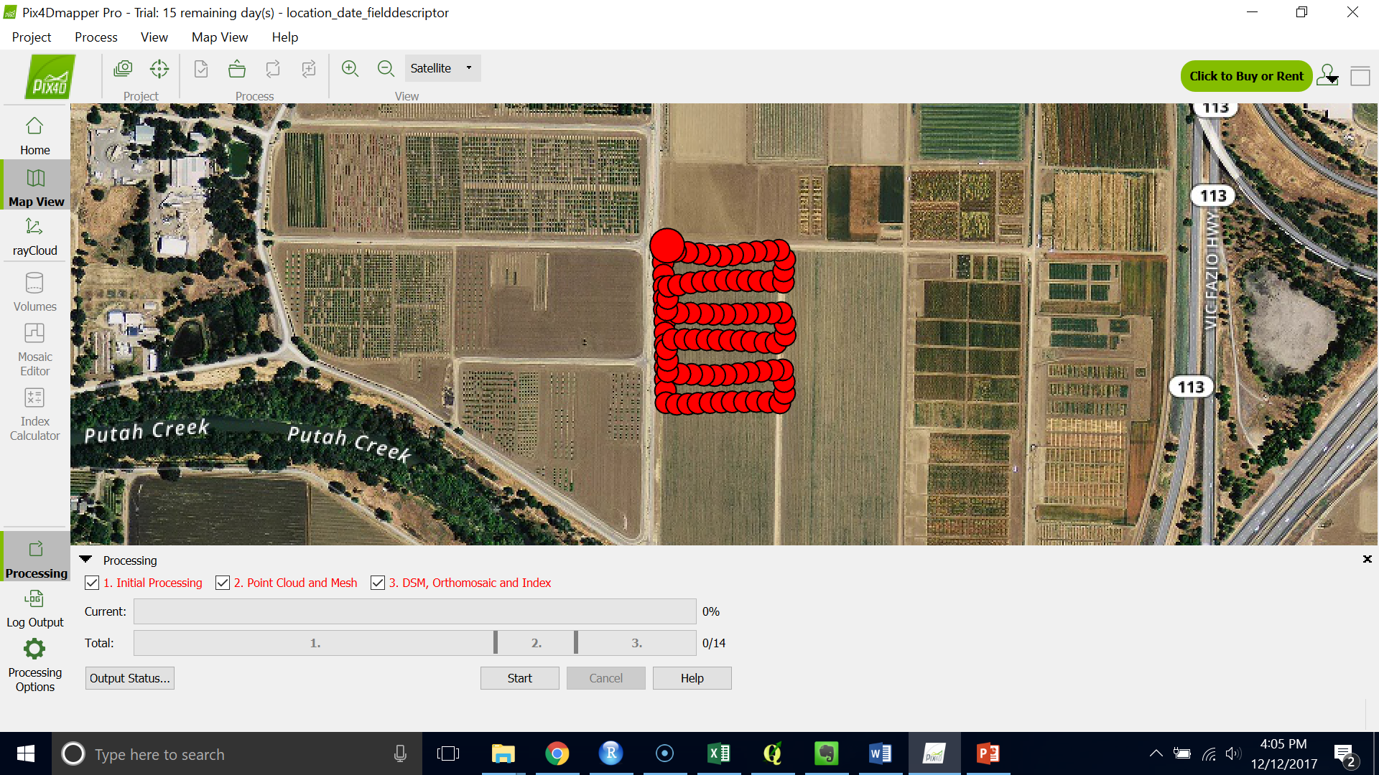

1. In the processing options, go to step 3 “DSM, Orthomosaic and Index”, then click “Index calculator” on top right.
2. Under “Radiometric Processing and Calibration”, check whether the calibration for each band is calibrated or not. If the symbol on the right of “Reset” is a yellow warning mark, the bands are not calibrated yet, follow the calibration instructions below. If the symbol is a green check mark, that means the bands are calibrated, go ahead to step 20.
3. Click “Calibrate…”, then click “browse” on top right, choose the calibrate images is from the target folder. (The calibrate image only show a panel in the image, which are different from other field image)
   1. For the Sequoia: Different bands have different names in calibrate images, green = “GRE”, red = “RED”, nir = “NIR”, red edge = “REG”. Choose the calibrate image that matches the band you click to calibrate.
   2. For the RedEdgeM see below:

REDEDGE RAW IMAGE BAND ORDER

IMG_0500_1.tif (Blue)  
IMG_0500_2.tif (Green)  
IMG_0500_3.tif (Red)  
IMG_0500_4.tif (Near Infrared)  
IMG_0500_5.tif (Red Edge)

1. Draw 4 points on the white broad of the panel (left bottom, do not overlap the lines between points), then follow the instruction, use a right mouse click to finish.
2. In the “Reflectance Factor” field, check for the band albedo values of our calibration panel (see below), input the value, and then click ok.

**Processing Software: Pix4D**

**Panel Serial Number: RP02-1648197-SC**

RedEdge  
Blue 0.55   
Green 0.55   
Red 668 0.55   
Red Edge 0.54   
Near IR 0.51

Sequoia  
Green 0.55  
Red 0.55  
Red Edge 0.54  
Near IR 0.52

**Panel Serial Number: RP03-1731298-SC**

RedEdge

blue 0.52  
green 0.53  
red 0.52  
nir 0.46  
re 0.50

Sequoia

green 0.52  
red 0.52  
nir 0.47  
re 0.5

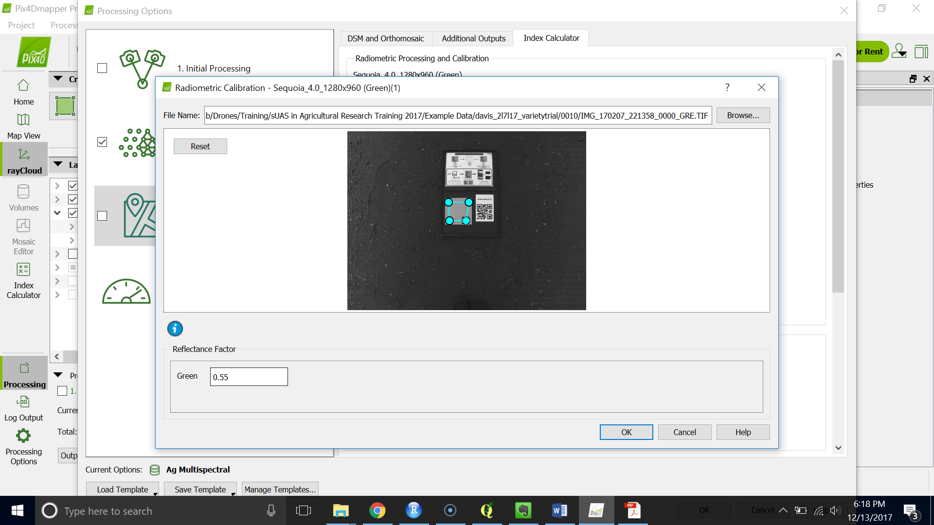

1. Once all the bands are calibrated, click “ok.”

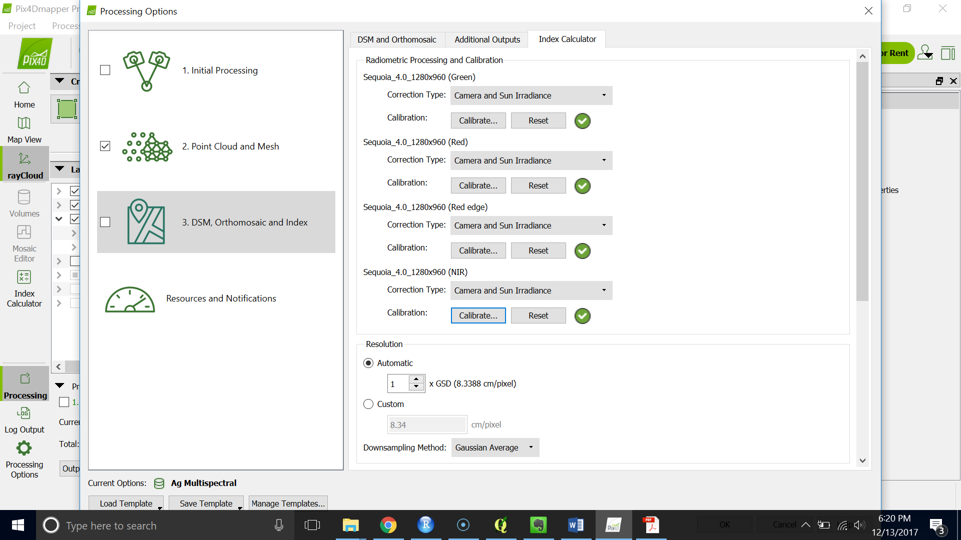

1. Scroll down and check the bands / indices you want to be generated.

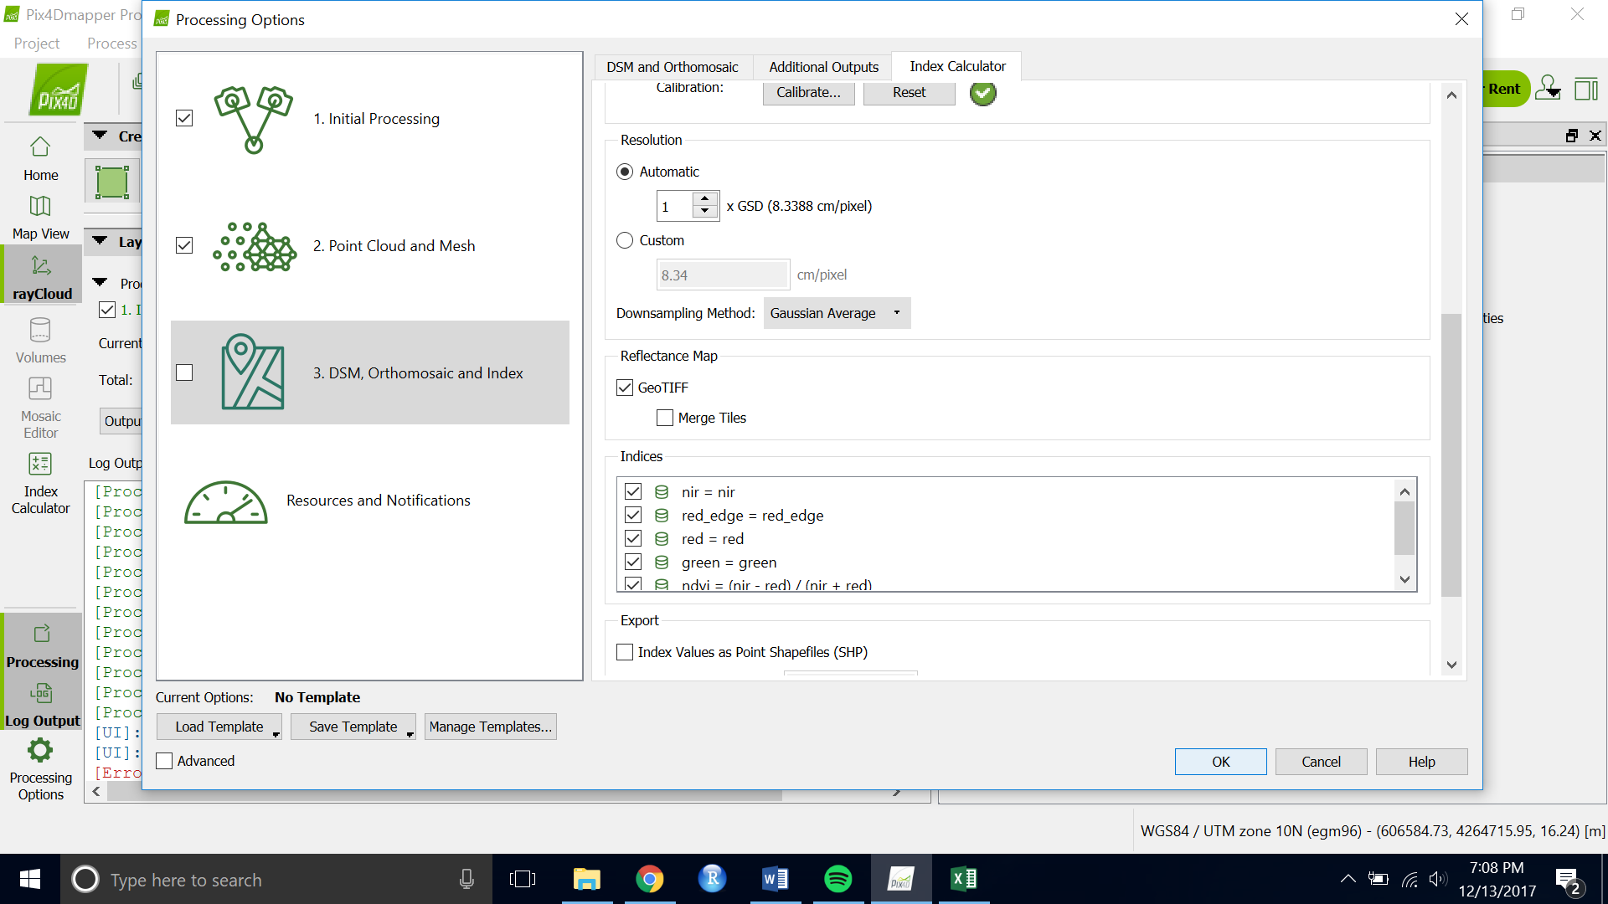

1. Change the Resolution from Automatic to custom at 10 cm/pixel. Click “ok”
2. Make sure that all boxes under “Processing” are selected and click “Start.”
3. When the images are finish stitching, check the final quality report. You should have 5+ images overlapping in your survey location.

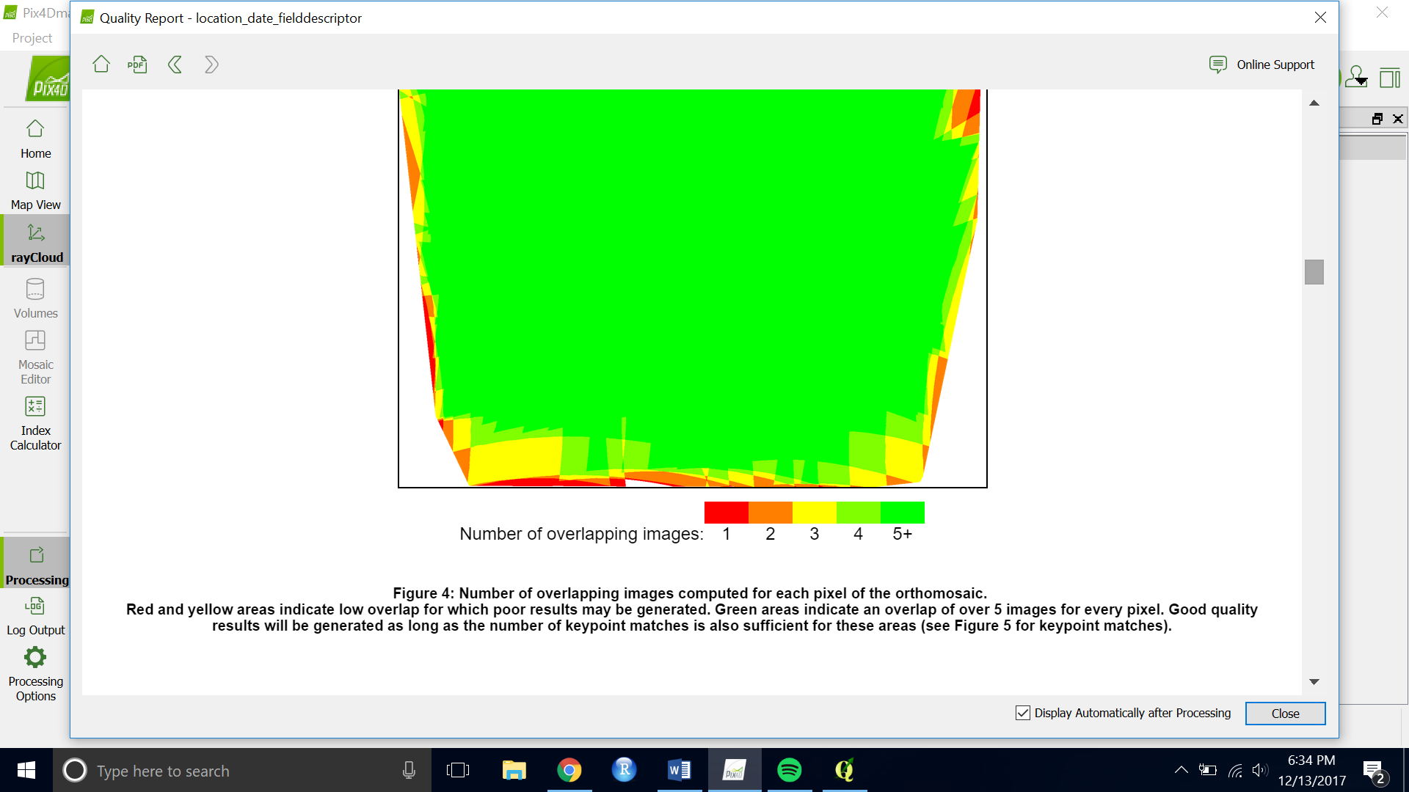

1. Go the index calculator on the far left side to view the stitched indices. 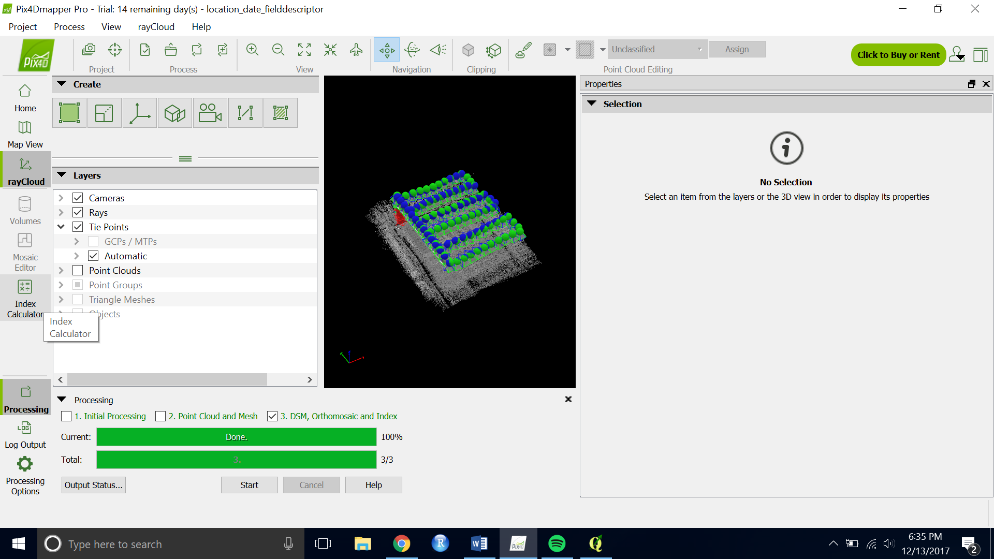
2. The index calculator should look like this.

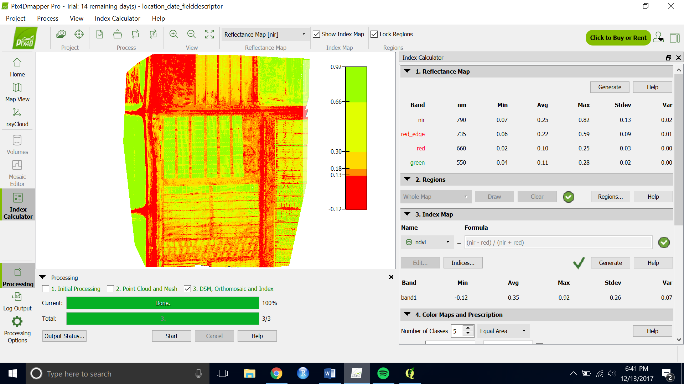

1. To add a new calculated indice from the images you just stiched, select “Indices…” under 3. Index map in the Index Calculator window.

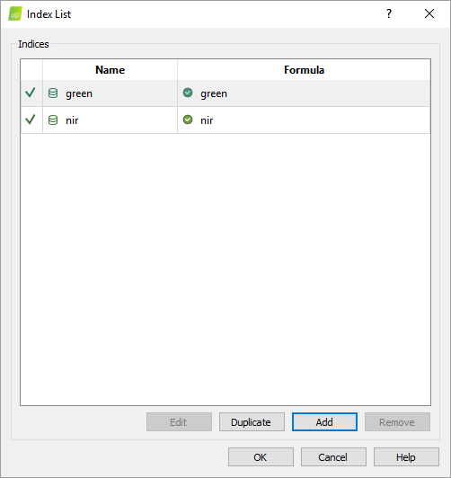

1. Click “Add” in the index list. Then use the bands and the operations to type your index of interest. Click “Ok”. You should now be able to load and view an image of your calculated indice.

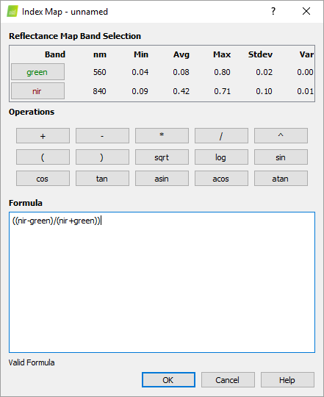

1. You should see all your tiff images that you will extract your pixel values from under \pix4d\project_name\4_index\indices
2. Open the quality report under \pix4d\project_name\1_initial